RoX Evaluation (4): SecondNet

Shuihai Hu, Wei Bai

1. Topology

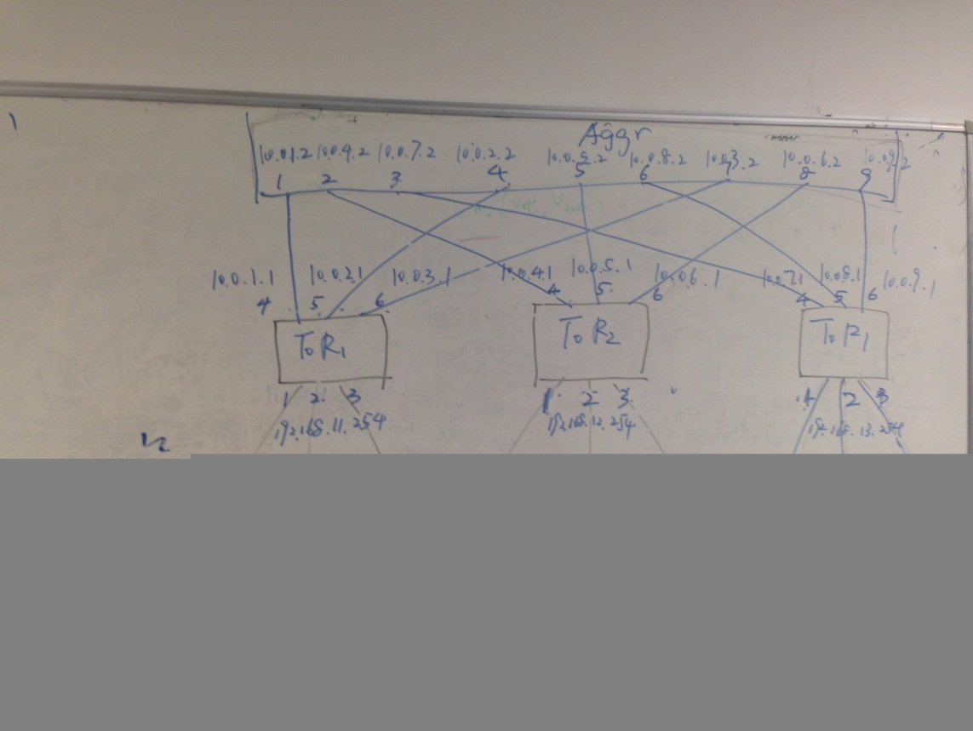

1. IP Setup

2.1 Machines

|  |  |  |  |
| --- | --- | --- | --- |
| Id | Hostname | Control IP | App IP |
| 1 | Sing40 | 192.168.1.40 | 192.168.11.1 |
| 2 | Sing41 | 192.168.1.41 | 192.168.11.2 |
| 3 | Sing42 | 192.168.1.42 | 192.168.11.3 |
| 4 | Sing43 | 192.168.1.43 | 192.168.12.1 |
| 5 | Sing44 | 192.168.1.44 | 192.168.12.2 |
| 6 | Sing45 | 192.168.1.45 | 192.168.12.3 |
| 7 | Sing46 | 192.168.1.46 | 192.168.13.1 |
| 8 | Sing47 | 192.168.1.47 | 192.168.13.2 |
| 9 | Sing48 | 192.168.1.48 | 192.168.13.3 |

2.2 Switches

2.2.1 Edge 1 (Controlled by Sing40)

|  |  |  |
| --- | --- | --- |
| Port | VLan | IP |
| ge-1/1/1 | 2 | 192.168.11.254/24 |
| ge-1/1/2 |
| ge-1/1/3 |
| ge-1/1/4 | 3 | 10.0.1.1/24 |
| ge-1/1/5 | 4 | 10.0.2.1/24 |
| ge-1/1/6 | 5 | 10.0.3.1/24 |

2.2.2 Edge 2 (Controlled by Sing41)

|  |  |  |
| --- | --- | --- |
| Port | VLan | IP |
| ge-1/1/1 | 2 | 192.168.12.254/24 |
| ge-1/1/2 |
| ge-1/1/3 |
| ge-1/1/4 | 3 | 10.0.4.1/24 |
| ge-1/1/5 | 4 | 10.0.5.1/24 |
| ge-1/1/6 | 5 | 10.0.6.1/24 |

2.2.3 Edge 3 (Controlled by Sing42)

|  |  |  |
| --- | --- | --- |
| Port | VLan | IP |
| ge-1/1/1 | 2 | 192.168.13.254/24 |
| ge-1/1/2 |
| ge-1/1/3 |
| ge-1/1/4 | 3 | 10.0.7.1/24 |
| ge-1/1/5 | 4 | 10.0.8.1/24 |
| ge-1/1/6 | 5 | 10.0.9.1/24 |

2.2.4 Aggr (Controlled by Sing43)

|  |  |  |
| --- | --- | --- |
| Port | VLan | IP |
| ge-1/1/1 | 2 | 10.0.1.2/24 |
| ge-1/1/2 | 3 | 10.0.4.2/24 |
| ge-1/1/3 | 4 | 10.0.7.2/24 |
| ge-1/1/4 | 5 | 10.0.2.2/24 |
| ge-1/1/5 | 6 | 10.0.5.2/24 |
| ge-1/1/6 | 7 | 10.0.8.2/24 |
| ge-1/1/7 | 8 | 10.0.3.2/24 |
| ge-1/1/8 | 9 | 10.0.6.2/24 |
| ge-1/1/9 | 10 | 10.0.9.2/24 |

1. ECMP Configurations
   1. Edge 1

|  |  |
| --- | --- |
| Route | Next hop |
| 192.168.0.0/16 | 10.0.1.2 |
| 10.0.2.2 |
| 10.0.3.2 |

* 1. Edge 2

|  |  |
| --- | --- |
| Route | Next hop |
| 192.168.0.0/16 | 10.0.4.2 |
| 10.0.5.2 |
| 10.0.6.2 |

* 1. Edge 3

|  |  |
| --- | --- |
| Route | Next hop |
| 192.168.0.0/16 | 10.0.7.2 |
| 10.0.8.2 |
| 10.0.9.2 |

* 1. Aggr

|  |  |
| --- | --- |
| Route | Next hop |
| 192.168.11.0/24 | 10.0.1.1 |
| 10.0.2.1 |
| 10.0.3.1 |
| 192.168.12.0/24 | 10.0.4.1 |
| 10.0.5.1 |
| 10.0.6.1 |
| 192.168.13.0/24 | 10.0.7.1 |
| 10.0.8.1 |
| 10.0.9.1 |

1. ROX Configurations

4.1 Path

|  |  |  |  |  |
| --- | --- | --- | --- | --- |
| ID | Src | Dst | Path | IP |
| 1 | M1 | M8 | M1,T1,A,T3,M8 | 192.168.13.52 |
| 2 | M1 | M8 | M1,T1,A,T3,M8 | 192.168.13.102 |
| 3 | M1 | M8 | M1,T1,A,T3,M8 | 192.168.13.152 |
| 4 | M8 | M1 | M8,T3,A,T1,M1 | 192.168.11.51 |
| 5 | M8 | M1 | M8,T3,A,T1,M1 | 192.168.11.101 |
| 6 | M8 | M1 | M8,T3,A,T1,M1 | 192.168.11.151 |
| 7 | M4 | M7 | M4,T2,A,T3,M7 | 192.168.13.51 |
| 8 | M7 | M4 | M7,T3,A,T2,M4 | 192.168.12.51 |
| 9 | M5 | M8 | M5,T2,A,T3,M8 | 192.168.13.202 |
| 10 | M8 | M5 | M8,T3,A,T2,M5 | 192.168.12.52 |
| 11 | M6 | M9 | M6,T2,A,T3,M9 | 192.168.13.53 |
| 12 | M9 | M6 | M9,T3,A,T2,M6 | 192.168.12.53 |

* 1. End Host RoX Configurations

|  |  |  |  |
| --- | --- | --- | --- |
| Machine (VM) | Control IP Address | IP address | Path |
| M1 | 192.168.1.40 | 192.168.11.1 | 192.168.11.51  192.168.11.101  192.168.11.151 |
| M2 | 192.168.1.41 | 192.168.11.2 |  |
| M3 | 192.168.1.42 | 192.168.11.3 |  |
| M4 | 192.168.1.43 | 192.168.12.1 | 192.168.12.51 |
| M5 | 192.168.1.44 | 192.168.12.2 | 192.168.12.52 |
| M6 | 192.168.1.45 | 192.168.12.3 | 192.168.12.53 |
| M7 | 192.168.1.46 | 192.168.13.1 | 192.168.13.51 |
| M8 | 192.168.1.47 | 192.168.13.2 | 192.168.13.52  192.168.13.102  192.168.13.152  192.168.13.202 |
| M9 | 192.168.1.48 | 192.168.13.3 | 192.168.13.53 |

* 1. Switch Configurations

ToR 1

|  |  |  |
| --- | --- | --- |
| Path ID | Destination | Next Hop |
| 1 | 192.168.13.52/32 | 10.0.1.2 |
| 2 | 192.168.13.102/32 | 10.0.2.2 |
| 3 | 192.168.13.152/32 | 10.0.3.2 |

ToR 2

|  |  |  |
| --- | --- | --- |
| Path ID | Destination | Next Hop |
| 7 | 192.168.13.51/32 | 10.0.4.2 |
| 9 | 192.168.13.202/32 | 10.0.5.2 |
| 11 | 192.168.13.53/32 | 10.0.6.2 |

ToR 3

|  |  |  |
| --- | --- | --- |
| Path ID | Destination | Next Hop |
| 4 | 192.168.11.51/32 | 10.0.7.2 |
| 5 | 192.168.11.101/32 | 10.0.8.2 |
| 6 | 192.168.11.151/32 | 10.0.9.2 |
| 8 | 192.168.12.51 | 10.0.7.2 |
| 10 | 192.168.12.52 | 10.0.8.2 |
| 12 | 192.168.12.53 | 10.0.9.2 |

Aggr

|  |  |  |
| --- | --- | --- |
| Path ID | Destination | Next Hop |
| 1 | 192.168.13.52/32 | 10.0.7.1 |
| 2 | 192.168.13.102/32 | 10.0.8.1 |
| 3 | 192.168.13.152/32 | 10.0.9.1 |
| 4 | 192.168.11.51/32 | 10.0.1.1 |
| 5 | 192.168.11.101/32 | 10.0.2.1 |
| 6 | 192.168.11.151/32 | 10.0.3.1 |
| 7 | 192.168.13.51/32 | 10.0.7.1 |
| 8 | 192.168.12.51/32 | 10.0.4.1 |
| 9 | 192.168.13.202/32 | 10.0.8.1 |
| 10 | 192.168.12.52/32 | 10.0.5.1 |
| 11 | 192.168.13.53/32 | 10.0.9.1 |
| 12 | 192.168.12.53/32 | 10.0.6.1 |